**SharePoint** Development Training

********************************

**-: Day 1:-**

**Introduction to SharePoint:**

SharePoint is a platform to support collaboration and Content management system.

It is a central web-based portal where we can manage document, social activities, data and information.

**SharePoint can do:**

1.) Collaboration -> Collaboration is the strong theme of SharePoint which means bringing people together through different types of collaboration such as enterprise content management.

2.) Interoperability -> Capability to build and deploy secure and custom solutions that integrate line of business data with SharePoint and Office.

3.) Platform->SharePoint is also a platform that supports extensibility, through a rich object model, a solid set of developer tools, and a growing developer community.

**History of SharePoint:**

SharePoint first launched in 2001 By Microsoft after that some more versions launched like:

* SharePoint 2001: In 2001, Microsoft launched SharePoint Portal Server (SPS) and SharePoint Team Services (STS). SPS provided three functions i.e., Portal, Document Management & Search. STS on the other hand with FrontPage and provided team workspaces for collaboration.
* SharePoint 2003;
* SharePoint 2007;
* SharePoint 2010;
* SharePoint 2013;
* SharePoint 2016: SharePoint 2016 enhance the hybrid infrastructure (merging SharePoint On-Premises sites with SharePoint Online) and to take advantage of recent innovations in cloud technology.

**Features of SharePoint:**

* Enterprise Search Engine,
* Enterprise Content Management, Business Data Catalog,
* Excel Services, Faster Site Creation,
* List, Libraries,
* We can develop site,
* Customise site,
* Create Rest API,
* By Using Rest API, we can insert data in site.

**Prerequisite:**

* HTML
* CSS
* JavaScript
* Bootstrap
* C#
* jQuery
* React js
* CSOM
* JSOM
* SQL

**Key Feature:**

* Business connectivity Services,
* Record Management,
* Advance Searching,
* Web content Management,
* Enterprise management,
* Record Management,
* Site,
* Search,
* Branding,
* Compatibility,
* Interoperability,

Two SharePoint Premises:

SharePoint online by subscription;

SharePoint on premises by instilling on our PC;

---------------------------------------------------------------------------------------------

**-: Day 2 :-**

**Introduction of SharePoint Development platform**

SharePoint is a platform to support collaboration and content management system. It is a central web-based portal. Using SharePoint, we can manage our colleague’s and our own documents, social activities, data, and information.

* It allows groups to set up a centralized, password-protected space for document sharing.
* Documents can be stored, downloaded and edited, then uploaded for continued sharing.
* SharePoint offers such a wide array of features that it is very challenging for any one person to be an expert across all the workloads.

**Learnt with sort demo of SharePoint:**

* Default template on SharePoint and way to customise according to the user requirement.
* How to add List and libraries into the site.
* Shown how to insert different component of SharePoint into the site.

**SharePoint Master Page:**

Master Page: SharePoint master pages provide the interface and overall layout of the pages on a SharePoint site. The common elements of a page – its header, navigation links, Site Actions menu, and so forth they are placed in the same areas regardless of the page you’re viewing.

---------------------------------------------------------------------------------------------

**-: Day 3 :-**

**Difference Between List and Libraries:**

**List:** A SharePoint list is like a table in a database or a table in excel. The SharePoint list will have rows and columns that we will use to store information. For example, we may like to store Training Course details like: Training Course Name, Duration, Price etc;

* It stores homogeneous data;
* Version control is not possible.

**Libraries:** SharePoint libraries are special types of lists that are created to store documents. Each file in a SharePoint document library is like one item. It also has columns or fields or properties.

SharePoint also provides various libraries for specific proposes like picture library, form library, etc.

* Different data can be stored like video, music, website etc,
* Version control is possible.

**SharePoint Site Hierarchy**

**Three-layer architecture of SharePoint:**

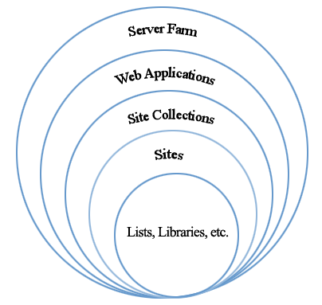

Figure : Diagram Shows the architectural hierarchy

**Server Farm:**  This is the top level of SharePoint; this level contains the Web Applications.

**Web Application:** This SharePoint instance contains the site collections.

**Site Collection:**  Site collections are at the third level within SharePoint hierarchy. The site collection has no parent site and as such is the first level of the hierarchy we can access. The site collection can create multiple sections underneath it which includes other sites/sub-sites and libraries.

**Site (Sub Site Collection):** The next level in the hierarchy are Sites, these are contained within the site collection, however, a site can have either a single parent or multiple parents within the site collection.

**List:** List and Libraries are the bottom level of the hierarchy. A SharePoint list is a collection of data that has some kind of structure to it

**Libraries:** SharePoint libraries are special types of lists that are created to store documents.

**********************************************************************************

**-: Day 4 :-**

**SharePoint List**

A SharePoint list is a collection of data that has some kind of structure to it. It is like a table, a spreadsheet or a simple database. It can include many different types of information including numbers, text and even images.

We can create and list that help to track issues, assets, routines, contacts, and more. Start from a template, Excel file, or from scratch.

**Create a list**

From SharePoint site home page

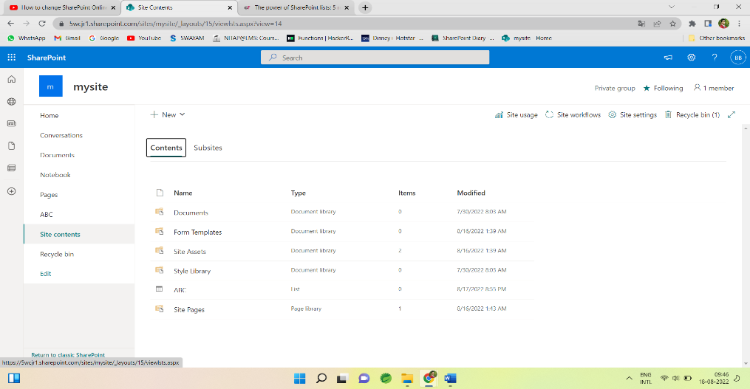

Or the Site contents page,

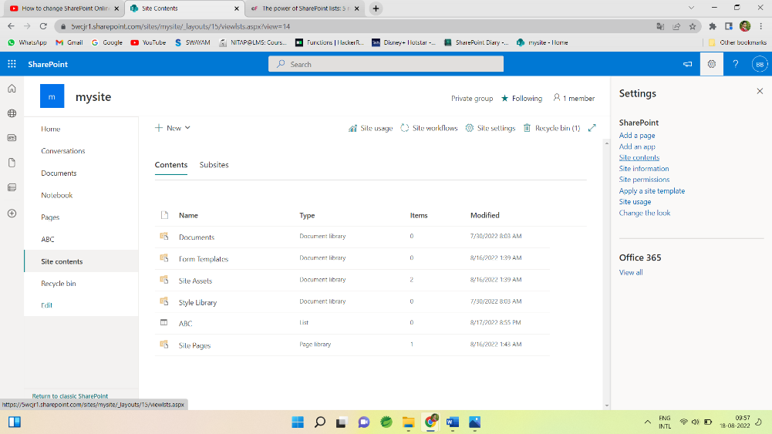

Then select -> + New -> List.

Now choose a Blank list and specify the name and description and List gets created

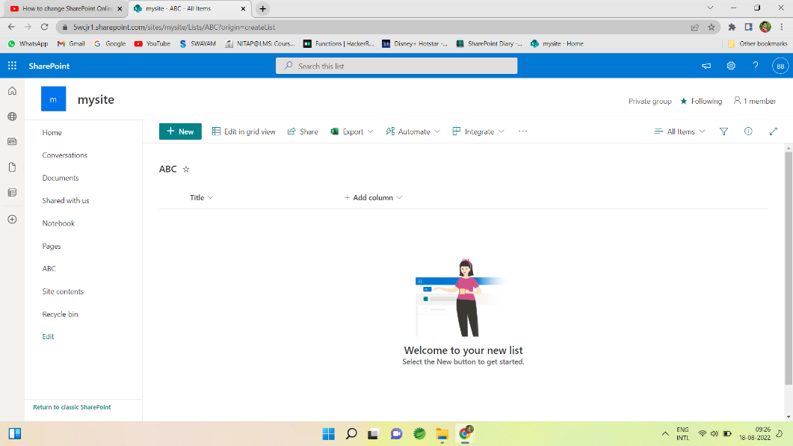

Now we can add column with specific type such as Number, Person, True/False, lookup, Image and many more by clicking on Add column option.

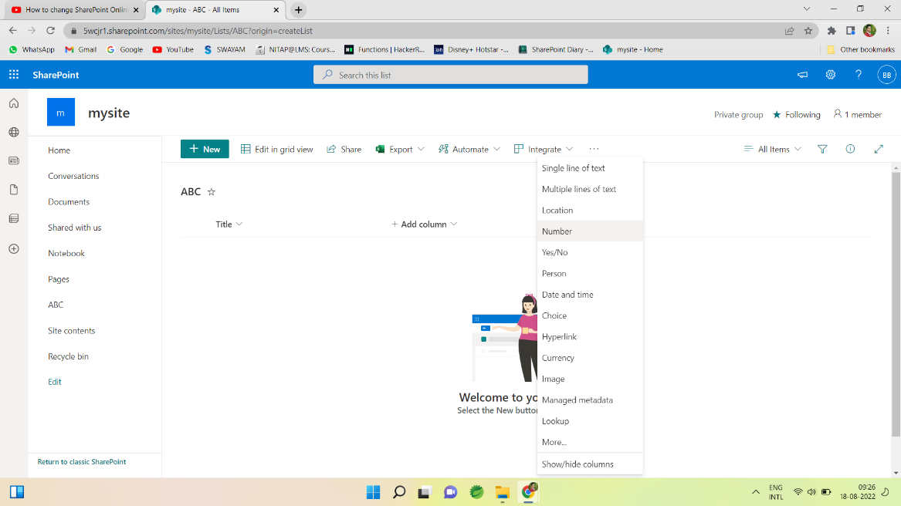

After Choosing the type of column we need to give name and description for that and column added to the list.

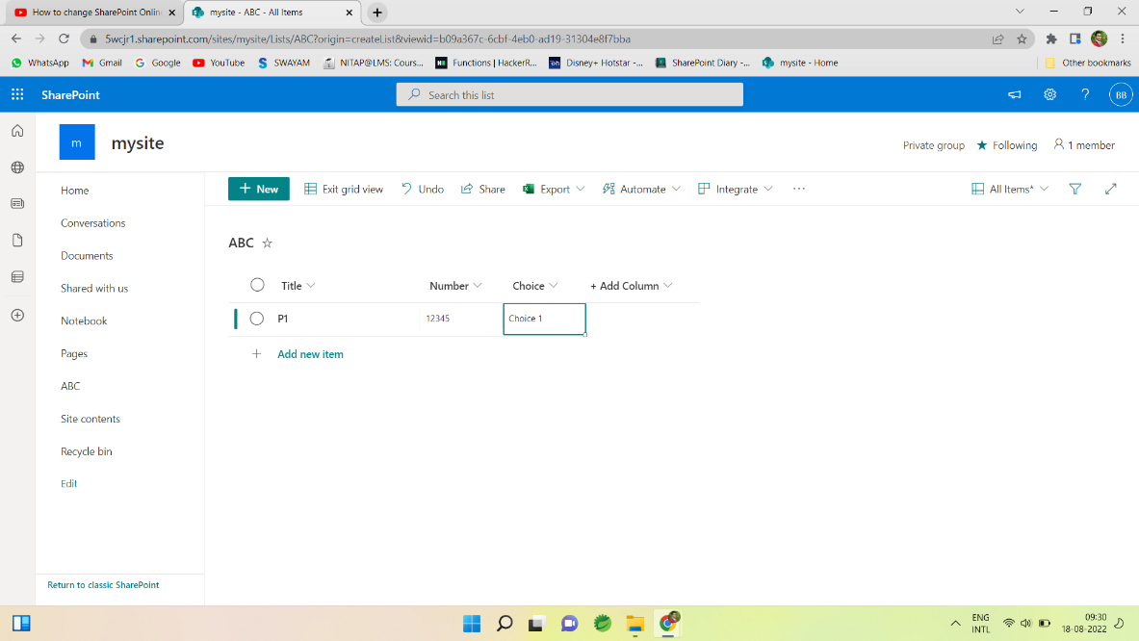

Similarly, we can add more column as requirement by its data type.

All created list is stored in site content which contain whole site content like list, libraries, documents etc.

After creating a list, we can edit list directly by clicking on Edit in grid view.

We can export as excel sheet by Export option.

*********************************************************************

Active Directory: Directory Which containing users, employee. Active Directory sync the users and after fetching we can extract all the necessary details.

Lookup: It is used to get the information from another table just like foreign key in SQL.

Calculated: SharePoint uses the calculated column to populate values based on some formula. The calculation can depend on other column values also, that can use other columns to calculate the values also.

**-: Day 5 :-**

**SharePoint View**

We can create custom views of lists and libraries to organize and show items that are important (like certain columns), to add filtering or sorting, or to have a more engaging style. You can create a personal view (that only you can see) or, if you have permissions to do so, you can create a public view for everyone who uses the list to see.

**Types of SharePoint views:**

* Standard view
* Datasheet view
* Calendar view
* Gantt view

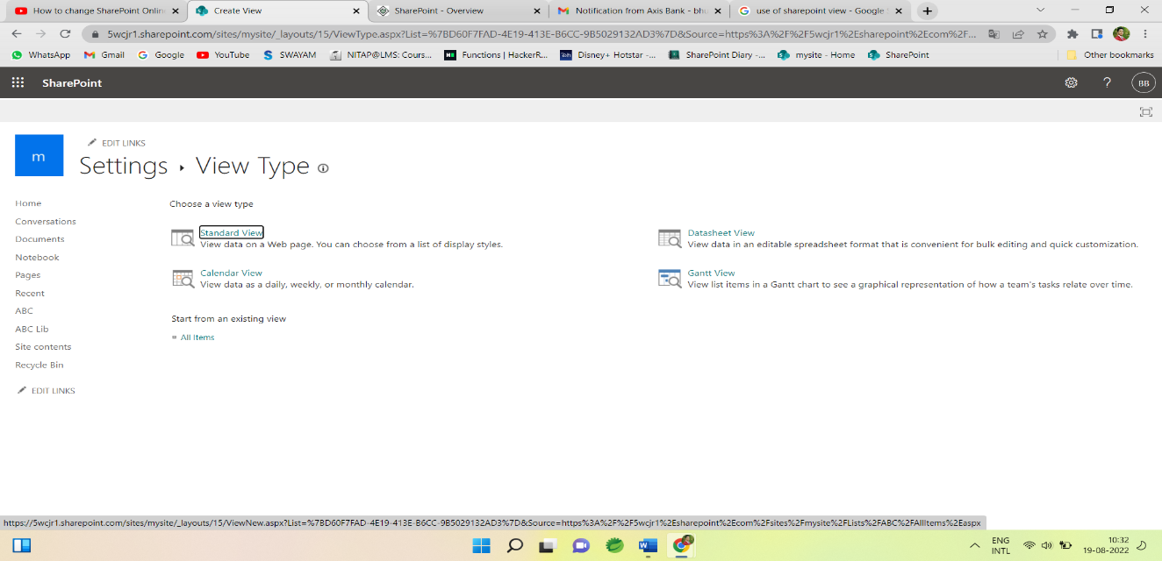

**By using this view we can use some functionality like:**

* Columns
* Filter
* Sort
* Tabular view
* Group by
* Talabs
* Style
* Folder
* Item Limit etc.

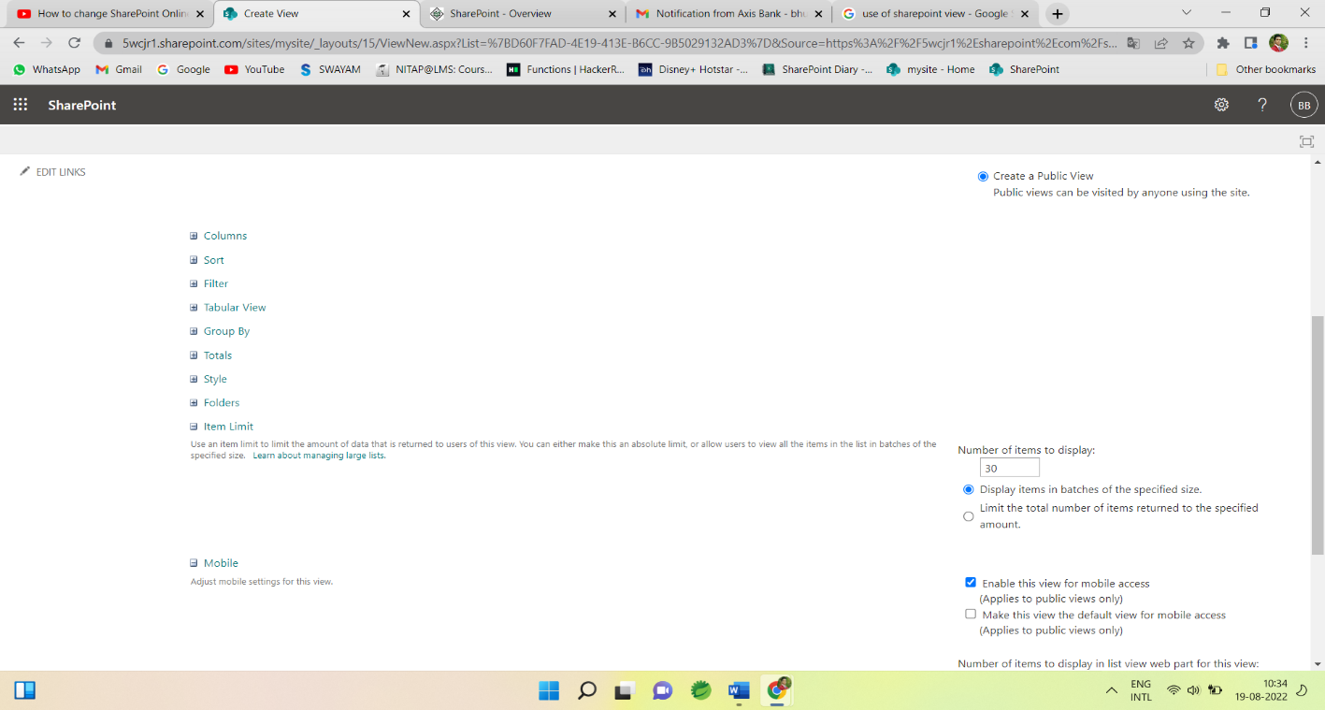

**Standard View:**  This view displays our list and library items one row following another. Standard view is the default for most types of lists and libraries. We can customize the view in many different ways, such as by adding or removing columns from the view.

**Calendar View:** This view displays our list and library in a format similar to a wall calendar. We can apply daily, weekly, or monthly views in this format. This view can be helpful if we want to see the items in the list or library chronologically. To use this view, list or library must contain columns with start dates and end dates for the calendar items.

**Datasheet View**: This view displays list and library items in a grid, similar to a spreadsheet. This view, also known as Quick Edit, can be helpful if we have to edit many items in a list or library at the same time. This view is also helpful if we want to export our data to a spreadsheet or database program. There are some limitations to Datasheet View - not all Excel functionality is available.

**Gantt View**: This view displays list and library items in bars that track progress, to see which tasks overlap each other and to visualize overall progress. To use this view, list or library must contain columns with start dates and end dates.

**SharePoint Library**

**Libraries:** SharePoint libraries are special types of lists that are created to store documents. Each file in a SharePoint document library is like one item. It also has columns or fields or properties.

SharePoint also provides various libraries for specific proposes like picture library, form library, etc.

* Different data can be stored like video, music, website, word file, pdf file etc,
* Version control is possible and important feature of SharePoint Library.

**Creation of SharePoint Library:**

Document library creation is same as List

Choose Site contents ->

Then select  + New -> Document Library.

Then Give name and Document library gets created.

In Document Library we can Store document like word file, excel file, music, video, website, link etc.